Project information – FYS9429

Introduction
The Hias wastewater resource recovery facility is located in Hamar, Norway, and treats municipal and industrial wastewater for the surrounding region, serving approximately 192,000 population equivalents (PE). The Hias Process is a novel continuous-flow moving bed bioreactor that integrates enhanced biological phosphorus removal with simultaneous nitrification and denitrification (MBBR-EBPR-SND).

Treatment Process Description
The wastewater treatment plant is a biological nutrient removal (BNR) system designed to remove organic matter, nitrogen, and phosphorus before discharge to the receiving water body.
The process consists of ten zones arranged in series:
- Zones 1–3: Anaerobic zones
- Zones 4–10: Aerobic zones
Wastewater flows through the process by gravity, while biomass carriers circulate continuously through all zones. The carriers provide surface area for biofilm growth, enabling biological nutrient removal.
Anaerobic Zones (1-3)
- Influent wastewater and biomass carriers enter the anaerobic zones first.
- The zones are mechanically mixed to ensure uniform distribution of carriers.
- No aeration is applied.
- These zones promote biological phosphorus release and prepare the biomass for subsequent aerobic uptake.
Aerobic Zones (4-10)
- The downstream zones are aerated to maintain sufficient dissolved oxygen concentrations.
- Aeration supports oxidation of organic matter, nitrification, and biological phosphorus uptake.
- Aeration rates are individually controlled for each aerobic zone.
Biomass Carrier Circulation
- After zone 10, the carriers are mechanically returned to zone 1 using a conveyor system.
- This creates repeated anaerobic–aerobic exposure cycles, which are essential for biological nutrient removal.
Solids separation and effluent discharge
- Biomass produced during the biological process is removed using a disc filter.
- The clarified effluent is discharged to the receiving water body.
- The plant operates under strict effluent requirements:
  - Phosphorus: below 0.4 mg/L (or >95% removal)
  - COD: below 125 mg/L (or >75% removal)

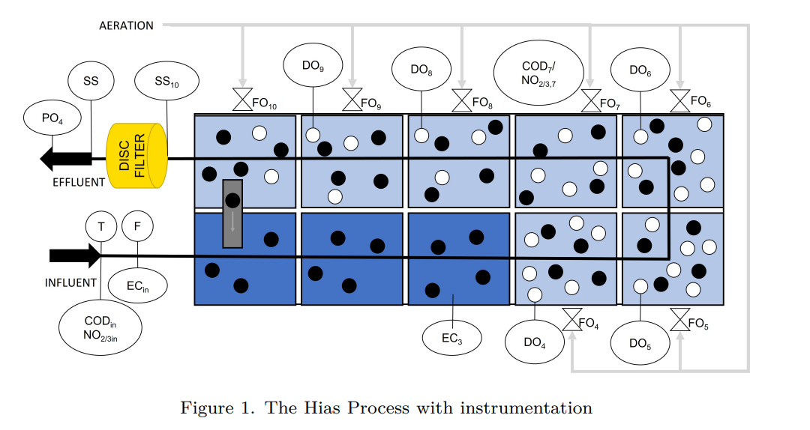

Available Measurement and Instrumentation
The process is equipped with online instrumentation providing continuous measurements.
Hydraulic and Physical Measurements
- Influent flow rate
- Temperature
- Electrical conductivity (inlet and zone 3)
Aeration and Oxygen Measurements
- Aeration rates in each aerobic zone (4-10)
- Dissolved oxygen concentrations in each aerobic zone (4-10)
Nutrient and Organic Matter Measurements
- Soluble organic matter measured as chemical oxygen demand (COD) (inlet and zone 7)
- Nitrate (NO3) (inlet and zone 7)
- Nitrite (NO2) (inlet and zone 7)
- Phosphate (PO4) (effluent)
Solids Measurements
- Suspended solids concentration (zone 10 and effluent after disc filter)

Dataset Characteristics
- Data available from July 2023 to January 2025
- One minute sampling interval
- COD/NO sensors have experienced severe malfunctions

What is already done?
For the HIAS process:
- Activated slugde model (ASM2d) for effluent nutrients estimation
- LSTM (w and w/o dynamic time delay) for effluent nutrients estimation
- Support vector regression (w and w/o dynamic time delay) for effluent nutrients estimation
- Development of virtual sensors for estimation of phosphates and COD
- Support vector machine for control strategies for optimizing aeration
- Gaussian process regression for control strategies for optimizing aeration
- Transfer functions for control strategies for optimizing aeration
- Activated sludge model for control strategies for optimizing aeration
- Transfer functions for effluent nutrients estimation
- ARX models for effluent nutrients estimation
- State-space models for effluent nutrients estimation

For Wastewater treatment plant modelling in academic literature:
- Physics-informed neural networks in water and wastewater systems: a critical review - ScienceDirect

